Different Gemini API key if exposed

I just got a mail form the Google AI studio after submitting the project that my previous API Key has been exposed as it is a rule for google that the API can not be used in public sharing platform like git.
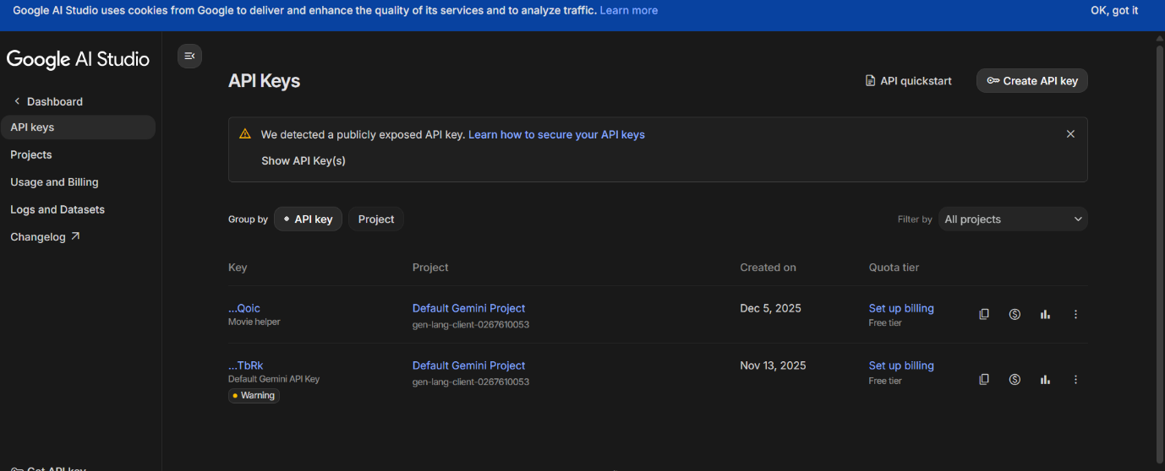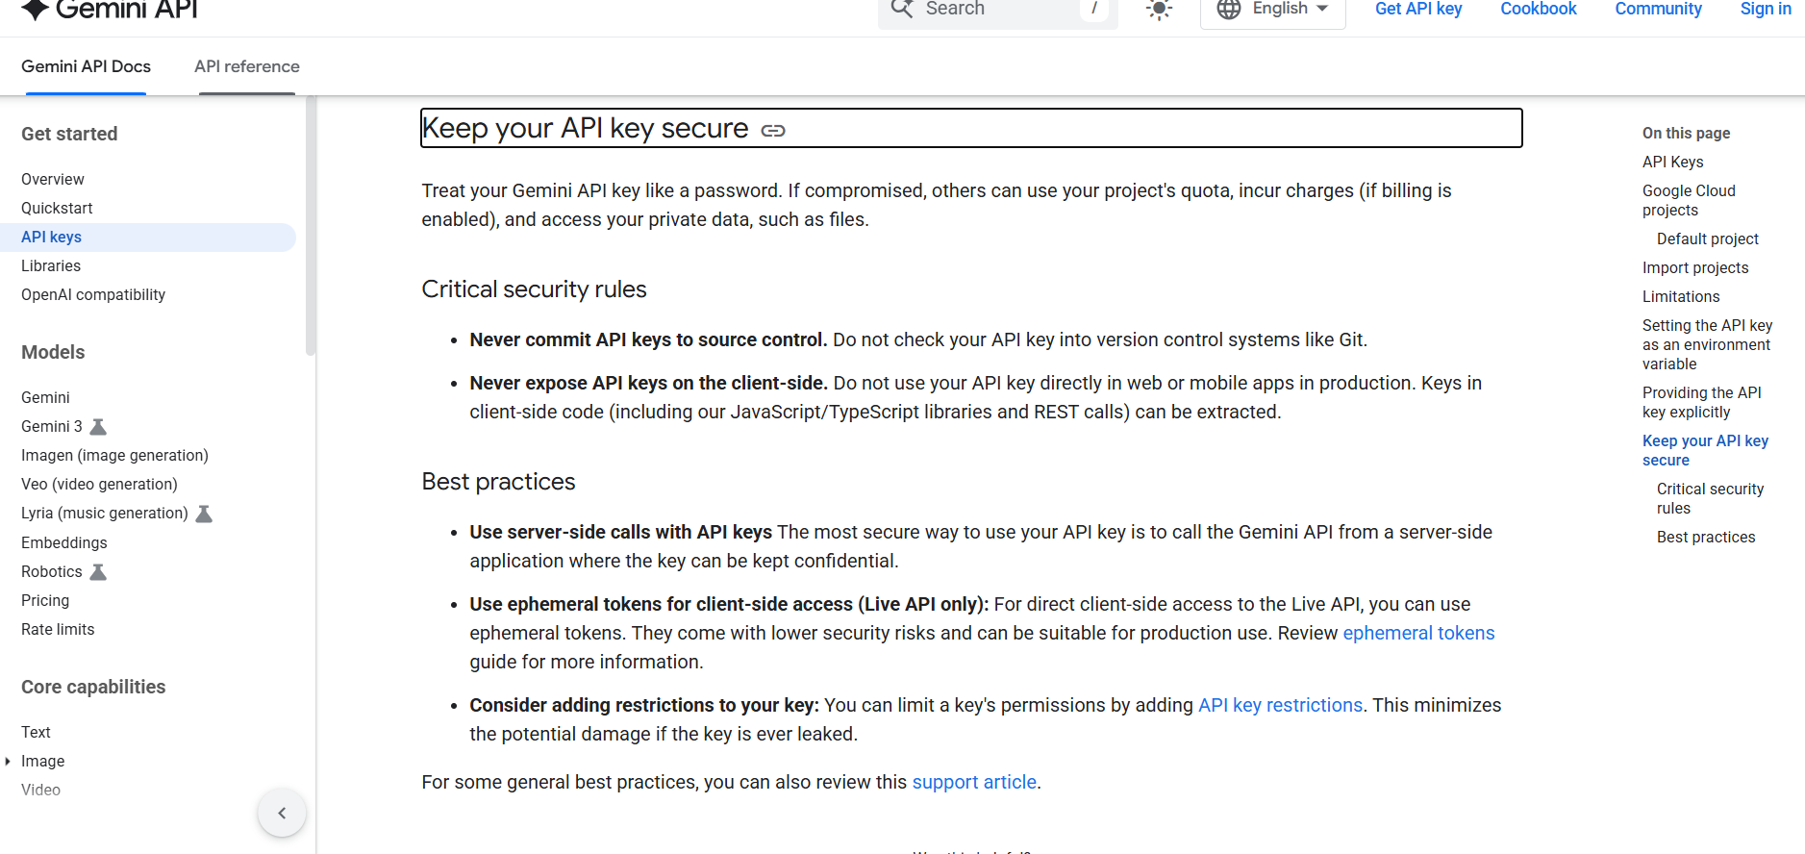
The Second key with Exclamation got exposed finishing with … bRk. This Api key is saved in the secrets.toml file in the Gemini API key section, if we look for it. So I created another API key for the section Ending with
…………Qoic
and at the first part of the API key instead of the dot dot you should add AIzaSyBVN6vPFe2rctHt5UkvwlCcnU7F5Ue……... before Qoic. Then make the fully made API onto the secrets.toml file where ethe previous gemini key is held. Thanks for your consideration. It will work smoothly as before.

